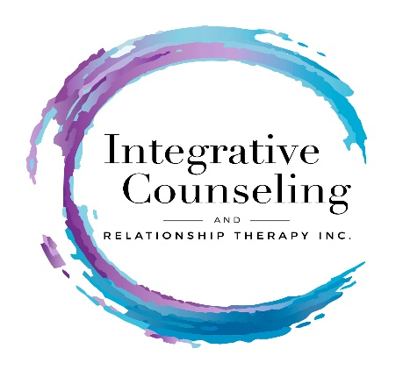

Relationship Questionnaire

Each person in the relationship/marriage completes a form.

Name ______________________________________________ Date ________

Address __________________________________________________________

_________________________________________________________________

Phone (H) ________________ (W) ________________ (C) ________________

Best number to contact you at ____________ May I leave a voice mail? ________

Email _________________________________ Birth date __________ Age _____

Place of Employment _________________________________________________

Position ___________________________________________________________

Spouse/Partner’s Name & Phone# ______________________________________

Duration of current relationship/marriage __________ Anniversary date ________

Have you ever separated? ___________________ If yes, how long for _________

Previous Marriages? ____Yes ____ No If so, length of marriage(s)
__________________________________________________________________

Ever widowed? _______________

Children? _____Yes _____ No How many? ______ Step-Children? _________

Names & Ages ___________________________________________________________________
___________________________________________________________________

Do you have any concerns about your children? ________ Please explain.
___________________________________________________________________
___________________________________________________________________ ___________________________________________________________________

Where do your children live?
__________________________________________________________________

Grandchildren? ______ How many? _____ Do you provide care? ______________

Other persons/pets living with you _______________________________________
___________________________________________________________________

Who referred you? __________________________ May I thank them? _______

Reason for Seeking Counseling

Reason for coming to relationship therapy (check all that apply):

____ communication issues ____ parenting issues

____ trust issues ____ other family issues

____ intimacy issues ____ affairs

____ financial issues ____ addiction issues

____ lack of time together ____ lack of shared interests

____ considering separating/divorcing ____ abusive issues

____ other (please explain _____________________________________________
___________________________________________________________________

In your words, say more as to why you are seeking counseling right now.
___________________________________________________________________
___________________________________________________________________
___________________________________________________________________
___________________________________________________________________

How long have these issues been of concern to you? ________________________

What psychological, emotional or physical symptoms are you experiencing as a result of these concerns/issues?
_________________________________________________________________
_________________________________________________________________

Specifically, what would you really like to change about your relationship?
_________________________________________________________________ _________________________________________________________________

Have you received professional help for your relationship prior to coming here today? If so, when, and for how long? Was it helpful?
________________________________________________________________
________________________________________________________________

How often do you spend time together, and what do you usually do? _________
________________________________________________________________ ________________________________________________________________

What do you really like about your relationship? __________________________
________________________________________________________________

On the scale below, how happy are you in your marriage/relationship right now?

unhappy somewhat happy happy

________________________________________________________________

1 5 10

Relationship History

How did you meet your partner and how long have you known her/him?
________________________________________________________________ ________________________________________________________________

When was the best period of time for you, in your relationship?
__________________________________________________________________ __________________________________________________________________

If living, do you get along with your parents? _____________________________

If living, do you get along with your partner/spouse’s parents? ________________

More About You

Which aspects of your own behavior are of concern to you, and what would you like to change in yourself to be a better partner?
___________________________________________________________________
___________________________________________________________________

Have you ever been hospitalized for psychiatric problems? ____________________

Have you ever experienced suicidal thoughts or feelings? ________ If yes, when?

__________________________________________________________________

Do you currently, or have you had any addictions? __________________________

Please explain. _____________________________________________________
__________________________________________________________________

Are you presently under a physician’s care? If so, for what condition?

Currently medications? _______________________________________________

Growing up, which parent were you closest to? ____________________________
And now? _________________________________________________________

Looking back, what do you believe your parents “did right” when raising you? __________________________________________________________________
__________________________________________________________________

What could your parents have “done better”? ______________________________
__________________________________________________________________

Were you close to any other extended family member? (i.e-grandmother). Please explain. ____________________________________________________________

What was the happiest period of time in your childhood? ______________________
___________________________________________________________________

Your Signature ____________________________________ Date _____________

Print Name _______________________________________________________

Integrative Counseling & Relationship Therapy, Inc.
Dr. Suzanne Nixon
19415 Deerfield Avenue Suite 307
Lansdowne, VA 20176

