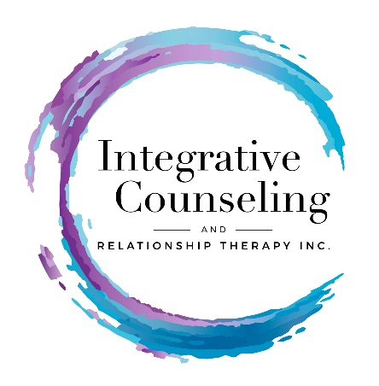

Informed Consent Agreement

The best relationships are those that are built on respect and understanding. My informed consent agreement gives you understanding as to my responsibilities as a therapist/healthcare practitioner and your responsibilities as a client.

Professional Statement

People seeking counseling want to better their lives. They are people who realize their personal, relational, family or professional life could be better. They have chosen counseling as a way to improve mood states, change unwanted behavioral patterns, resolve issues, work on relationship conflict or improve their relationships and increase self- understanding. Counseling is a safe place to explore your thoughts, feelings and issues, and receive professional support from a third person. Often people gain a new perspective of themselves/situation, work with specific issues, develop skills for better communication, and discover ways towards a happier, healthier and more fulfilling life.

Therapeutic Services and Wellness Services Are Provided
Individual Counseling, Marriage & Relationship Counseling, Family Therapy, Group Therapy, Wellness Counseling, Wellness Groups, Integrative Health Coaching

Fees, Payment & Insurance Questions
Fees are expected to be paid at the time of your session. I prefer checks, due to the cost of credit card charges. However, I do credit cards. You may also pay through my paypal account. My rates are posted on the professional fee handout.

I am fee for service, and do not participate with insurance companies. If you have a PPO insurance plan, your insurance company will reimburse you for a % of your counseling fee. Some wellness services are now covered by insurance companies. Call your company and ask for more information about behavioral healthcare and wellness service reimbursement.

Participation
For counseling to be beneficial and for you to be successful in meeting your goals, a regular and consistent attendance is essential. Counseling services are initially scheduled weekly, for a period of 4 weeks. Thereafter, we determine whether to stay with weekly sessions, or change to bi-monthly, etc. Length of counseling sessions are 50-minutes, however, initial sessions are 75 minutes. Sometimes clients prefer 75- minute sessions routinely and it varies from client to client. Most people are in counseling for 4 to 12 months, depending on their mental well-being and goals. Groups are held on a term basis, anywhere from 6 to 12 weeks and are run weekly.

Scheduling
Initial appointments can be scheduled by phone or email. Subsequent sessions are scheduled at the time of your appointment. I will try to give you a “regular” day and time. Sessions begin and end on time. If you are late for a session, I do not go overtime.

Weather
During inclement weather, when road conditions may be hazardous, I will call/email you in the morning to let you know whether sessions will be scheduled. If you believe the roads are too hazardous and unsafe, call as soon as possible to cancel your session. There will be no cancellation.

Closure
Coming to closure in the counseling process is a significant point. Please plan for one or two closure sessions.

Confidentiality
In the counseling relationship, information about you is kept confidential. This includes all information regarding you and our work together, i.e.: your history, diagnosis and treatment. Please read the HIPPA form for more information.

Please Note: The Zoom Platform does not have upgraded confidential securities. Please initial your understanding and agreement to use the Zoom.com tool for the moment. _____

Emergencies and Out of Town
When I am out of town, and you are experiencing an emergency, please:
- Call 911, or Go to your nearest emergency facility, or
- Call your primary care physician or your psychiatrist

Please check the service below you are coming for:
______ Initial Consult ______ Family Therapy
______ Individual Counseling ______ Divorce Counseling
______ Marriage or Relationship Therapy ______ Wellness Counseling or Service
______ Walk & Talk Therapy ______ Group

Questions, please ask!
Please read and initial each statement.

_____I have read this consent agreement and agree to the terms of service.

_____I accept full responsibility for payment of services.

_____________________________________________________________________
Your Signature Printed Name Date

