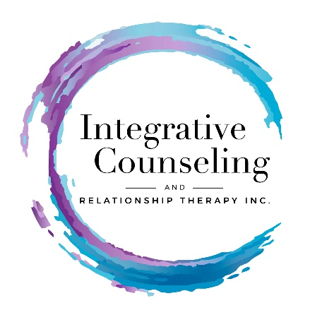

Adolescent Questionnaire

Please provide the following information and answer the questions below.

Name __________________________________________ Date _________

Birth Date _______________________ Age ________ Grade _____________

School __________________________________________________________

Address ____________________________________________ Zip _________

Phone (H) ________________ (W) ________________ (C) _______________

Best contact phone number? __________ Email _________________________

Who do you live with?
_____ Both parents _____ One parent _____ Parent’s Friend

_____ My parents are divorced and I live between parents on a scheduled routine.

____ Other Please explain _________________________________________

Parents Contact Information
Mother’s Name: ___________________________________________________
Mom’s phone: Cell____________________ Work ____________________

Dad’s Name: _____________________________________________________
Dad’s phone: Cell ____________________ Work _____________________

Do you have siblings? Their names and ages?
________________________________________________________________
________________________________________________________________
________________________________________________________________

Do they live with you? ______________________________________________

Do you have step brothers/sisters? Their names and ages?
__________________________________________________________________ __________________________________________________________________
__________________________________________________________________
Which siblings/step-siblings do you get along with?
__________________________________________________________________

Which siblings/step-siblings do you Not get along with?
__________________________________________________________________

Who do you tend to spend the most time with/ hang out with in your family?
__________________________________________________________________

Does your family spend time together? If yes, what kind of family activities do you do? ___________________________________________________________________
___________________________________________________________________

How often do you take family vacations? Where do you go? Are they fun?
___________________________________________________________________
___________________________________________________________________

Have you ever been in counseling? ______________________________________

Do you want to be in counseling now? ____________________________________

How can I help you?
___________________________________________________________________
___________________________________________________________________

In the past month, which feelings have you experienced?

____Sad ____ Angry ____ Happy ____ Frustrated ____Peaceful

Do you consider yourself a: (circle the one you feel the most):

Happy Person Sad Person Angry Person

Have you ever thought about harming yourself or have harmed yourself?
If so, have you thought of how? Please explain: _________________________
_______________________________________________________________
_______________________________________________________________

If you have hurt yourself, how? ______________________________________
_______________________________________________________________
_______________________________________________________________
_______________________________________________________________

What would you like to change about you, or about your family situation?
________________________________________________________________
________________________________________________________________
________________________________________________________________

What do you like about school?
______________________________________________________________________

What do you dislike about school? __________________________________________
______________________________________________________________________

Do you have a best friend, or group of friends you hang out with?
______________________________________________________________________

What do you enjoy doing with your friends? And how often do you get together?
______________________________________________________________________
______________________________________________________________________

Have you ever been bullied? Yes or No. If yes, please explain.
______________________________________________________________________
______________________________________________________________________
______________________________________________________________________

Are you presently being bullied? If yes, please explain.
____________________________________________________________________________________________________________________________________________

If yes, (check all that apply)
___ at school
___ on my school bus or walk to school
___ on my sport team
___ in my neighborhood
___ at church
___ at home

What are your hobbies & interests? _________________________________________
_____________________________________________________________________

Do you play sports? Which ones? On a team?
_____________________________________________________________________ _____________________________________________________________________

Do you have any health/medical issues? Are you on medication? If yes, please explain.
_____________________________________________________________________
_____________________________________________________________________

Is there anything else you would like me to know?
_____________________________________________________________________
_____________________________________________________________________
_____________________________________________________________________
_____________________________________________________________________

If under 18 please have parent or legal guardian read, sign and date this portion.

Please note that Integrative Counseling & Relationship Therapy Center, Inc. does not participate with insurance companies. Payment is due at the time of service, and clients file their claims with their insurance company. If you have a PPO insurance plan, we recommend you contact your insurance company and ask for their reimbursement %.

Please initial. _______

Client/Parent Signature ________________________________ Date _______

Print Name _______________________________________________________

Integrative Counseling & Relationship Therapy, Inc.
Dr. Suzanne Nixon
19415 Deerfield Avenue Suite 307
Lansdowne, VA 20176

